2022-2023 Gulf Breeze High School Men’s Soccer

Strength and Fitness Program

The best teams and players work year-round to be their best. This means that, in order to be the best, we must be working to constantly better ourselves.
This means WE:
- Are Responsible For Our Own Fitness
- Work To Get Out of Our Comfort Zones
- Find Satisfaction in Working Hard
- Touch the Soccer Ball As Often As Possible
- Push Ourselves For the Good of the Team

Championships are EARNED, not given.

Success is not a quick fix. It is a LONG-TERM Investment.

One of the key requirements of a good soccer team is conditioning and the key to any conditioning program is the mind of the athlete involved. No matter how good the program may be, nothing is truly accomplished unless the individual athlete actually DOES the
work necessary to find success.

Any soccer training program should be based on one simple observation: soccer is a game that requires you to run. A LOT. You must be able to run long distances and move in many different ways. When you train for soccer specific fitness, you should be doing two things: playing as much soccer as possible and replicating the physical demands of soccer in your training routine.

Our program focuses on the seven main components in soccer specific conditioning: endurance, speed, flexibility, strength, agility, explosiveness and ball skills. This packet is designed to help get you where you want to be through a Summer offseason of work.

Table of Contents:

1. Guidelines Page 3

2. Conditioning Program Pages 4-6

3. Description of Exercises Page 7

4. Body Circuit Page 8

5. Speed/Agility Drills – Explained Pages 9-14

6. Strength/Weight Program Pages 15-18

“Success is no accident. It is hard work, perseverance, learning, studying, sacrifice and most of all, love of what you are doing or learning to do.”

- Pele’

Gulf Breeze Soccer Fitness Guidelines:
1. Always warm up properly before any workout
2. Always keep a written record of your workouts
3. The best way to stay on track with a workout program is to work out with
a motivated partner/group
4. Push Yourself – especially on the days you don’t feel energetic
5. Avoid back-to-back days for workouts of the same type or using the same
muscle groups; give yourself time to recover
6. Listen to your body. Take care of any injuries
7. Fitness levels develop gradually over time, not in peaks and valleys
8. Playing soccer is the best way to get soccer fit
9. Vary your workouts so your work remains fresh

Once you feel ready to get started, ask yourself the following question:
How many times a week do I participate in organized training or play competitive
games?

For many of you during the Summer, the answer is “Not Much.”

For this situation, playing less than 90 minutes of competitive soccer per week, you will need to complete FOUR Cardio workouts per week, along with at least THREE weight workouts per week
If you play more than this, you should cut out one of the cardio workouts from your training program.

2022-2023 Fitness & Conditioning Program
Be sure that a warm-up and stretch is completed before you start each conditioning session. A sufficient warm-up should last at least 5-10 minutes and allow you to break a sweat. Following the warm-up spend another 5-10 minutes stretching. After completing the workout spend another 5-10 minutes stretching to decrease muscle soreness. Descriptions of exercises are in the back of this program packet.
Phase One
Week 1 (June 6-10th)

Monday, Wednesday, Friday Tuesday, Thursday
1 Mile Run @ 8:00 min/mile pace 2 Mile Run @ 8:00 min/mile pace
10 x 80 Yard Sprints 10 x 80 Yard Sprints
5 x 25 Situps, 5 x 25 Pushups 5 x 25 Situps, 5 x 5 Pushups

Week 2 (June 13-17th)

Monday, Wednesday, Friday Tuesday, Thursday
1 Mile Run @ 8:00 min/mile pace 2 Mile Run @ 8:00 min/mile pace
10 x 80 Yard Sprints 10 x 80 Yard Sprints
5 x 25 Situps, 5 x 25 Pushups 5 x 25 Situps, 5 x 5 Pushups

Week 3 (June 20-24th)

Monday, Wednesday, Friday Tuesday, Thursday
1 Mile Run @ 7:30 min/mile pace 2 Mile Run @ 7:30 min/mile pace
10 x 80 Yard Sprints 10 x 80 Yard Sprints
5 x 30 Situps, 5 x 25 Pushups 5 x 30 Situps, 5 x 5 Pushups

Week 4 (June 27- July 1st)

Monday, Wednesday, Friday Tuesday, Thursday
1 Mile Run @ 7:30 min/mile pace 2 Mile Run @ 7:30 min/mile pace
10 x 80 Yard Sprints 10 x 80 Yard Sprints
5 x 30 Situps, 5 x 25 Pushups 5 x 30 Situps, 5 x 5 Pushups

Week 5 (July 4-8th)

Monday, Wednesday, Friday Tuesday, Thursday
1 Mile Run @ 7:00 min/mile pace 2 Mile Run @ 7:00 min/mile pace
10 x 80 Yard Sprints 10 x 80 Yard Sprints
5 x 30 Situps, 5 x 25 Pushups 5 x 30 Situps, 5 x 5 Pushups

Week 6 (July 11-15th)

Monday, Wednesday, Friday Tuesday, Thursday
1 Mile Run @ 7:00 min/mile pace 2 Mile Run @ 7:00 min/mile pace
10 x 80 Yard Sprints 10 x 80 Yard Sprints
5 x 30 Situps, 5 x 25 Pushups 5 x 30 Situps, 5 x 5 Pushups

Phase Two: (See Pages 7-14 for Explanations)

Week 7 (July 18-22nd)

Monday Tuesday
2 Mile Run @ 7:30 min/mile pace 2 x 400m, 2 x 300m, 2 x 200m
Two Tower, Compass & Funnel Runs Shuttle Run – 3 Sets
Body Circuit Training Body Circuit Training

Thursday Friday
3 Mile Run @ 7:30 min/mile pace 1100 Yard Shuttle Run
120’s 5 – 10 – 5 Ladders & Funnel Run
Body Circuit Training Body Circuit Training

Week 8 (July 25-29th)

Monday Tuesday
Shuttle Run – 4 Sets Test Run (1 mile – 6 minutes, .5
120’s Mile – 3 minutes, 400m – 1:20, Body Circuit Training 200m – 35s, 100m – 15s)
Two Tower Run & Funnel Run
Body Circuit Training

Thursday Friday
2 Mile Run @ 7:00 min/mile pace 3 Mile Run @ 7:30 min/mile pace
Hand Run, 5 – 10 – 5 Ladders 300 Yard Shuttle Run
Body Circuit Training Body Circuit Training

Week 9 (August 1-5th)

Monday Tuesday
Shuttle Run – 4 Sets Test Run (1 mile – 6 minutes, .5
120’s Mile – 3 minutes) Body Circuit Training Half Laps
Body Circuit Training

Thursday Friday
1100 Yard Shuttle 2 each x 400m, 300m, 200m, 100m
10 x 25 Situps, 3 x 25 pushups 10 x 25 Situps, 3 x 25 Pushups
Hand and Funnel Runs Body Circuit Training

Week 10 (August 8-12th)

Monday Tuesday
Shuttle Run – 4 Sets Test Run (1 mile – 6 minutes, .5
120’s Mile – 3 minutes)
Body Circuit Training Half Laps
Body Circuit Training

Thursday Friday
1100 Yard Shuttle 2 each x 400m, 300m, 200m, 100m
10 x 25 Situps, 3 x 25 pushups 10 x 25 Situps, 3 x 25 Pushups
Hand and Funnel Runs Body Circuit Training

Week 11 (August 15-19th)

Monday Tuesday
4 Mile Run @ 7:30 min/mile pace Test Run (1 mile – 6 minutes, .5
10 x 25 Situps, 3 x 25 pushups Mile – 3 minutes)
Body Circuit Training Half Laps
Body Circuit Training

Thursday Friday
1100 Yard Shuttle 2 each x 400m, 300m, 200m, 100m
120’s 10 x 25 Situps, 3 x 25 Pushups
Body Circuit Training Body Circuit Training

Description of Exercises
DYNAMIC WARM UP (Perform before each conditioning session)
• High-knee walk – stepping forward, grabbing the shin of the opposite leg and pulling the knee towards the chest. Extend the stepping leg and get up on the toes.
• High-knee walk with external rotation – grasp the shin (instead of the knee) with a double overhand grip and pull the shin to waist height. Extend the hip of the supporting leg while rising up on the toes.
• A-skip – gentle skipping designed to put the hip musculature into action. No
emphasis on height or speed only rhythmic action.
• Heel ups – shifts emphasis from the hip flexors to the hamstrings. Actively warms up the hamstrings as well as move the quads through full range of motion.
• High-knee run – similar to running in place with a small degree of forward movement. Emphasis is on maintaining an upright posture and getting a large number of foot contacts. The key to this exercise is to maintain perfect posture.
• Straight leg skip – increases the dynamic stretch of the hamstring while activating the hip flexor. Hands are held at shoulder height and rt. foot goes up to the rt. hand.
• Straight leg dead lift walk - reach both arms out to the side while attempting to lift one leg up to waist height. To move forward, swing the back leg through to take one giant step. Only one trip. Walking lunges on the way back.
• Walking lunges w/ side lunge – lunge walk forward then lateral lunge to the same side. (i.e. lunge forward with the right, then lunge lateral with the right).
• Giant carioca – facing laterally, lead with the trail leg. The trail leg crosses over the lead leg above knee height. When the trail leg becomes the lead leg make sure the toes are facing up field.
• Backward run – emphasis is on actively pushing with the front leg while
reaching out aggressively with the back leg.
• Forward sprint – Forward sprint-turn to backward run

BODY CIRCUIT TRAINING
Each exercise is to be performed for 45 seconds with a 30 second rest in between exercises.
Do 2 rotations of the assigned body circuit with a 3-minute rest in between circuits.
Prior to starting the circuit, make sure you do the following:
1. 5-minute warm-up - any type of cardio or running.
2. A comprehensive full body stretch.

1. Squat Jumps
2. Lunges – alternate legs.
3. Bicycle crunches - hands behind head, legs off the ground, opposite elbow to knee.
4. Push ups
5. Broad jumps – jump as far out as you can. Yes for 45 seconds
6. Bench dips – hands on a bench or chair, feet straight out on the floor, lower yourself until upper arm is parallel with the floor
7. Burpees – jump, hands on ground, extend your legs into a push up position, legs back to chest, jump.
8. Clap Pushups
9. Hip ups – lie on your back, legs straight up in the air, shoot your hips to the ceiling.
10. Bicycle Jumps – right foot in front, left foot back, jump as high as possible and alternate feet – 20 jumps
11. Mountain Climbers – keep knee over your ankle
12. Front Plank
13. Side Plank – Alternate sides

Speed and Agility Drills, Explained

300 Yard Shuttle: The 300-yard shuttle is a very tough agility movement. The athlete will be going a twenty-five-yard distance. The objective is to move between the lines as quickly as possible until 12 complete trips are completed, which equals 300 yards. The goal is to complete the drill in less than 65 seconds and to continue improving the time. **There are 12 direction changes in this drill.

120’s: 120’s is a test designed to measure a player’s ability to run longer distances. 120 yards is the equivalent to the length of a normal soccer field. The player starts at one end of the field and must sprint to the other end. At the end the player has the remainder of the minute to rest. The rest involves a jog back to the starting point. For example, if a player runs the 120 in 20 seconds, they will have 40 seconds to run back to the start line. There is extra rest time after runs #5, 10, and 15.
Goal = 10 consecutive sets all completed in under one minute.

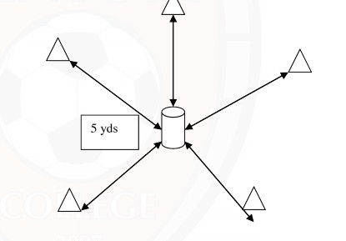Compass Run: Place 5 cones 5 yards away from the middle marker as shown above. Start in the middle and sprint to a cone and back to the middle, continue to run to each cone (5 runs). Repeat 5 times with a 30 second break between each set.

9

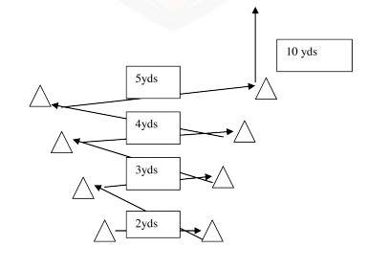Funnel Run: Sprint laterally; keep the knees bent and shuttle side to side, when you reach the last cone sprint forward 10 yards and walk back to the start.
Repeat 6-8 times

5-10-5 Short Ladders: Start in a sport specific position and sprint 5 yards out. Touch the line and sprint to the starting line. Next sprint 10 yards, touch the line, and sprint back. Continue with the last 5 yards out and back. Change sprints into shuffle, carioca, and backpedal. Also change the direction the athlete turns after touching the line.
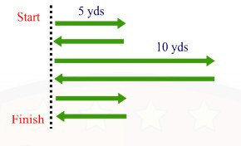Repeat 8 times

V

10

Two Tower Drill: Begin drill by backpedaling ten yards and then either shuffle/carioca ten yards to cone. Again, backpedal another ten yards and shuffle/carioca ten yards through cone. Next sprint ten yards to cone and shuffle/carioca ten yards and finish with a ten-yard sprint to the last cone.
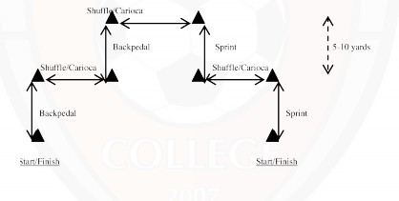Repeat 8 times

Hand Run: Begin at the START cone and sprint forwards to the 1st cone and then sprint backwards to the start cone, then sprint forwards to the 2nd cone and backwards to the start cone, continue to do the same for the 3rd, 4th & 5th cone… this equals one set.
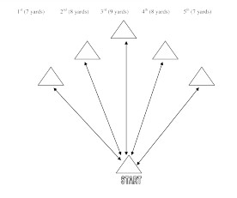Workload: 6-8 sets with a 30 second rest between each set

11

Super Weave: Start on either side of the drill and sprint through the entire drill while weaving in and out of each cone, touch each cone before continuing.
Workload: 6-8 sets with a 30 second rest between each set

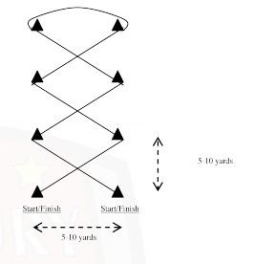

Half Laps: Using a standard soccer field (110-120yds * 70-80yds) start where the centerline & touchline meet. Sprint around the perimeter of the field (behind the goal) and finish at the opposite side of the field (where the other touchline & centerline meet). You will be running 2 half fields and one width. When you complete the half lap immediately jog across the centerline. When you reach the original starting point,
repeat sprint & jog. You have 30 seconds to complete the half lap and 30 seconds for the recovery jog across the centerline.
Time Limit: 30 seconds
Rest Period: 30 seconds (jog) Repetition: 6 half laps
Workload: approximately 180-190yds each half lap * 6 = 1080yds-1140yds
Time Duration: 6 minutes
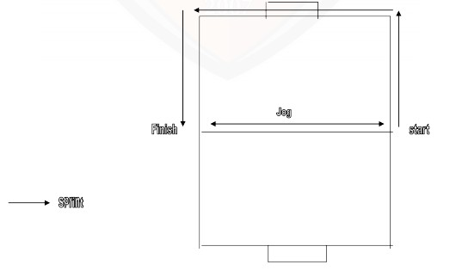

1100-yard Shuttle Run: Put a cone down (on a level surface) as a starter marker and then place seven cones the exact distance from the starter marker as drawn above. Run from the starter marker to the 1st cone and back, and then to the 2nd cone and back, 3rd cone and back,
4th cone and back, 5th cone and back, 6th and back, 7th and back. After
each run your heart rate will be around 90% - 95% of your maximum heart rate.
Time Limit: 4 minutes
Rest Period: 2 minutes Repetition: 4 shuttles Workload: 4400 yds Time Duration: 22 mins

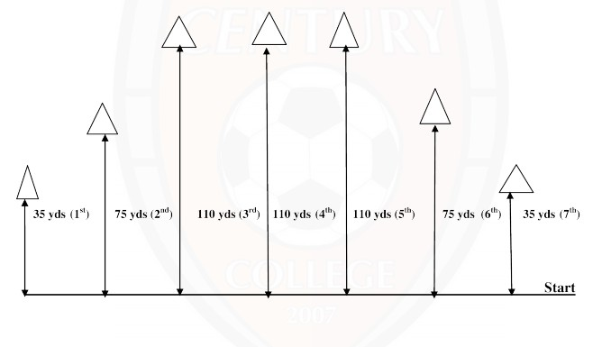

Strength Training Examples
Generally speaking, you will want to lift weights a minimum of THREE times a week. A
general rule of thumb is to lift Monday, Wednesday, Friday for three workouts a week and
Monday, Tuesday, Thursday, Friday for four workouts a week.
It is crucial to give your muscles opportunity to rebuild themselves after you work them. To keep agility and explosive power, we look to go low weight with high reps. High weight and low reps adds mass, while sacrificing flexibility.

Monday, Wednesday, Friday BASIC Workout Example

Workout will consist of:
a. One push exercise d. One push exercise b. One pull exercise e. One pull exercise
c. One leg exercise f. One leg exercise
REPEAT IN ORDER
g. 5 Abdominal exercises, 20 repetitions each

*NOTE: THIS IS AN EXAMPLE. YOU CAN CHANGE THE SPECIFIC EXERCISES TO VARY YOUR WORKOUTS

IN THIS ORDER:
Bench Press, 12 reps – Push
Chin-ups, 12 reps – Pull Walking Lunges, 12 each leg – Leg Dumbbell Shoulder Press, 12 reps – Push Dumbbell Rows, 12 reps – Pull
Step-ups, Knee to Chest, 12 each leg – Leg
Bench Press, 12 reps – Push Chin-ups, 12 reps – Pull
Walking Lunges, 12 each leg – Leg Dumbbell Shoulder Press, 12 reps – Push Dumbbell Rows, 12 reps – Pull
Step-ups, Knee to Chest, 12 each leg – Leg
Abdominal Exercises Crunches, 30
V-sit, Side to Side, 30 Hip Lifts, 30 Bikes, 30 Obliques, 30

Monday, Wednesday, Friday EXPLOSIVE STRENGTH Workout
Example

Workout will consist of:
a. One push exercise d. One explosive push exercise
b. One pull exercise e. One pull exercise
c. One explosive leg exercise f. One explosive leg exercise REPEAT IN ORDER
g. 5 Abdominal exercises, 20 repetitions each

*NOTE: THIS IS AN EXAMPLE. YOU CAN CHANGE THE SPECIFIC EXERCISES TO VARY YOUR WORKOUTS

IN THIS ORDER:
Dumbbell Curl to Shoulder Press, 12 Reps – Push
Pull-Ups, Knee to Chest, 12 Reps – Pull Box Jumps, 12 total – Explosive Leg
Clap Pushups, 12 Reps – Explosive Push Dumbbell Rows, 12 Reps – Pull
Diagonal Lunges, 12 each leg – Explosive Leg Dumbbell Curl to Shoulder Press, 12 Reps – Push Pull-Ups, Knee to Chest, 12 Reps – Pull
Box Jumps, 12 total – Explosive Leg Clap Pushups, 12 Reps – Explosive Push Dumbbell Rows, 12 Reps – Pull
Diagonal Lunges, 12 each leg – Explosive Leg
Abdominal Exercises Hip Lifts, 30
Double Leg Bikes, 30 Toe Touches, 50 Superman – 30
V-sit, side to side, 30

Monday, Wednesday, Friday 12 STATION CIRCUIT Workout
Example – These are good if you don’t have a weight room
EACH EXERCISE WILL BE DONE FOR 30-45 SECONDS, WITH
30 SECOND REST IN BETWEEN

Workout will consist of:
1. One push exercise 7. One fast footwork drill
2. One explosive leg exercise 8. One abdominal exercise
3. One abdominal exercise 9. One explosive push exercise
4. One agility exercise 10. One leg exercise
5. One pull exercise 11. One pull exercise
6 One abdominal exercise 12. One abdominal exercise
THEN REPEAT IN ORDER

*NOTE: THIS IS AN EXAMPLE. YOU CAN CHANGE THE SPECIFIC EXERCISES TO VARY YOUR WORKOUTS

IN THIS ORDER:
1. Dumbbell Shoulder Press, Both Shoulders – Push (Can use anything for weight)
2. Cross Country skiers – Explosive Leg
3. Crunches – Abdominal Exercise
4. Burpees – Agility Exercise
5. Chin Ups – Pull
6. Hip Lifts – Abdominal Exercise
7. Ali Shuffle – Fast Footwork Drill
8. Toe Touches – Abdominal Exercise
9. Clap Pushups – Explosive Push
10.Diagonal Lunges – Leg
11.Dumbbell Rows – Pull (Can use body weight and towel/wall)
12.Double Bikes – Abdominal Exercise

THEN REPEAT IN ORDER

“It’s the days when the body aches, the
desire is low, you feel weak and you feel tired… Those are the days that CHAMPIONS train.”

Gulf Breeze Soccer doesn’t ask you to anything you aren’t capable of; neither does life. What you do with your time, the sacrifices you make, the passion you show, all reveal who you will become in the future.

When you look at the guy next to you, dripping in sweat, what motivation will you pull from within? The work you put in now will be the thoughts that fill your head in the heat of battle, not just for yourselves, but for your teammates, the players who have played before you, and ALL the players yet to come.

YOU set the EXPECTATIONS FOR SUCCESS. YOU and your willingness to do the WORK. YOU have the power to make this program GREAT.

